1. Bernoulli Equation may be interpreted physically to mean that the total mechanical energy is conserved for a control volume:

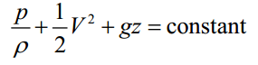

1. What conditions is this relation based upon?
2. Please list a few applications of Bernoulli Equation in life.
3. In some cases, the use of Bernoulli Equation is invalid. Then how should we extend Bernoulli Equation for these cases?
4. The siphon can transport the water from the reservoir to irrigation canals. Assume the vertical height z from the highest point to the exit point of the siphon is 6 m and the exit point is 3 m lower than water surface of the reservoir, as shown in figure below. If we need 100 m3 of water per hour, try to determine the diameter of the siphon d. If the temperature of water is 20 ℃ (the saturated vapor pressures of water is 2340 Pa accordingly), and the local atmospheric pressure is 1.0133×105 Pa, determine whether the siphon can transport water normally.

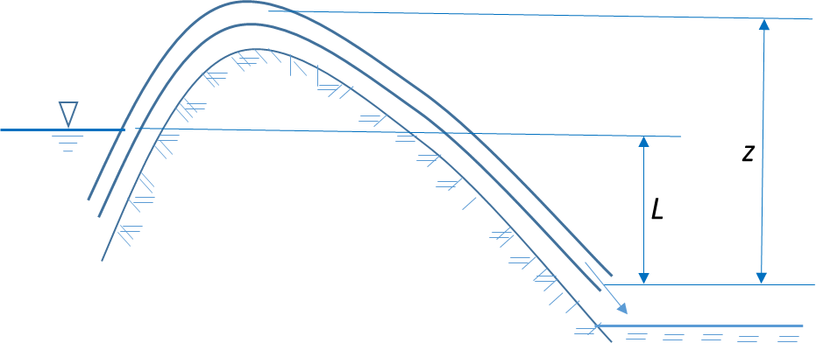

1. A fan draws air from the atmosphere through a 0.30-mdiameter round duct that has a smoothly rounded entrance. A differential manometer connected to an opening in the wall of the duct shows a vacuum pressure of 2.5 cm of water. The density of air is 1.22 kg/m3. Determine the volume rate of air flow in the duct in cubic feet per second. What is the horsepower output of the fan?

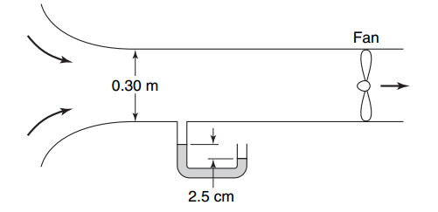

1. Multnomah Falls in Oregon has sheer drop of 165 m. Estimate the change in water temperature caused by this drop. [The total energy (the sum of mechanical energy and internal energy) is conserved.]